Mixed Curvilinear Shapes
# Source: AI Source: Provided by: [Data Path: Persons Table -> ID Column: 1, Name_En Column: Motasem Essam] -> From: [ChatGPT] on [7/25/2026]
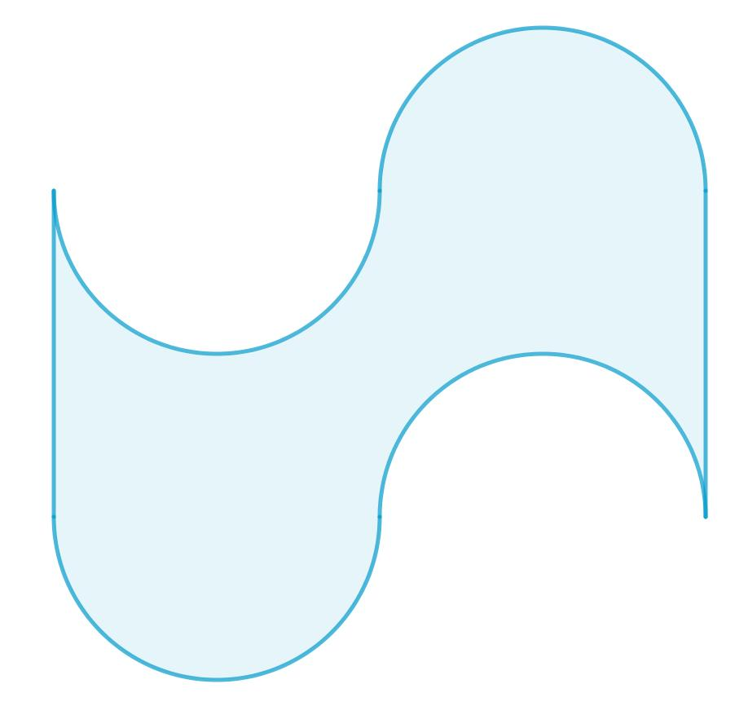
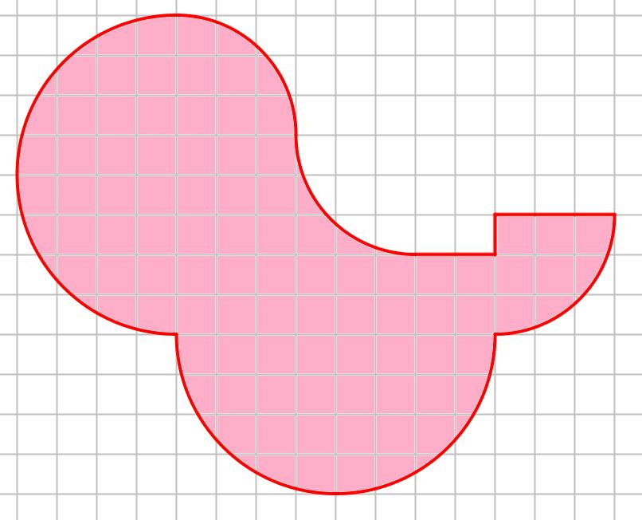
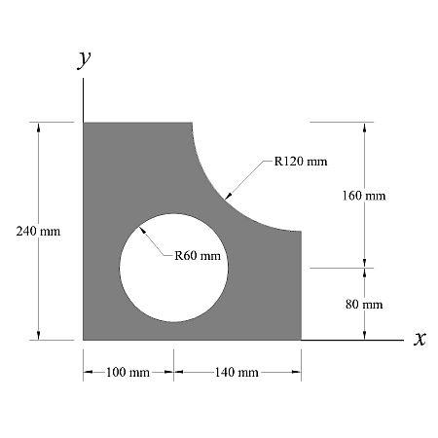
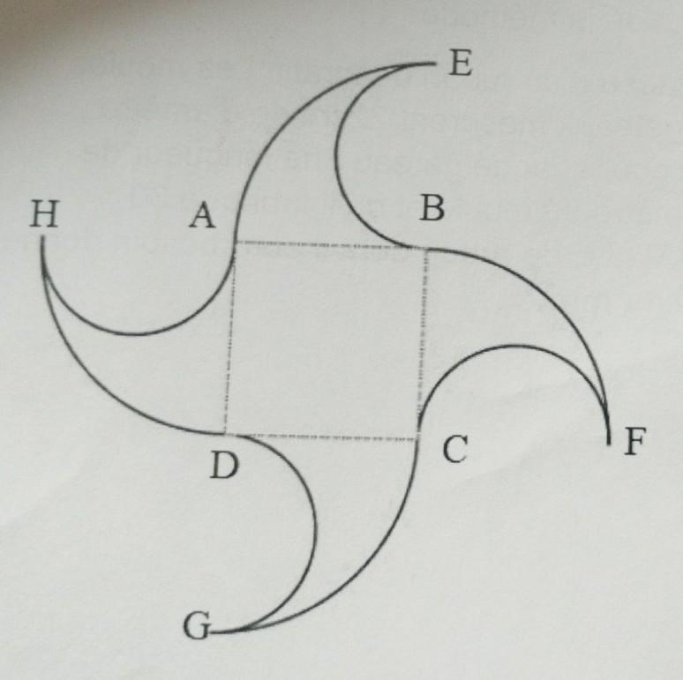

Definition
# Source: AI Source: Provided by: [Data Path: Persons Table -> ID Column: 1, Name_En Column: Motasem Essam] -> From: [ChatGPT] on [7/25/2026]
Mixed Curvilinear Shapes are shapes whose boundaries or structures combine different types of curved elements, or combine curved elements with other geometric boundary elements, within the same overall shape.
The word mixed indicates that more than one type of geometric or curvilinear element is present.
For example, a mixed curvilinear shape may combine:
- circular arcs
- elliptical arcs
- freeform curves
- wavy curves
- straight-line segments
Unlike a circle or ellipse, a mixed curvilinear shape does not necessarily follow one single curve type.

Fundamental Concept
# Source: AI Source: Provided by: [Data Path: Persons Table -> ID Column: 1, Name_En Column: Motasem Essam] -> From: [ChatGPT] on [7/25/2026]
The fundamental idea is:
$$\boxed{\text{Mixed Curvilinear Shape}=\text{Multiple Boundary or Curve Types}}$$
A mixed shape can be represented using several curve segments.
For example:
$$r\left(t\right)=\left\{\begin{matrix}r_{1}\left(t\right), & t_{0}≤t<t_{1} \\ r_{2}\left(t\right), & t_{1}≤t<t_{2} \\ r_{3}\left(t\right), & t_{2}≤t≤t_{3}\end{matrix}\right.$$
Each portion may represent a different curve.

Main Characteristics
# Source: AI Source: Provided by: [Data Path: Persons Table -> ID Column: 1, Name_En Column: Motasem Essam] -> From: [ChatGPT] on [7/25/2026]
Mixed curvilinear shapes can have:
- multiple curve types
- different radii
- different curvature
- different curve equations
- straight and curved portions
- smooth or sharp transitions
- open or closed boundaries
- regular or irregular arrangements
- symmetric or asymmetric structures
- simple or complex boundaries
The defining feature is the combination of different elements.

Types of Mixed Curvilinear Shapes
# Source: AI Source: Provided by: [Data Path: Persons Table -> ID Column: 1, Name_En Column: Motasem Essam] -> From: [ChatGPT] on [7/25/2026]
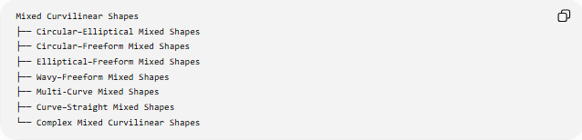
Mixed Curvilinear Shapes
├── Circular–Elliptical Mixed Shapes
├── Circular–Freeform Mixed Shapes
├── Elliptical–Freeform Mixed Shapes
├── Wavy–Freeform Mixed Shapes
├── Multi-Curve Mixed Shapes
├── Curve–Straight Mixed Shapes
└── Complex Mixed Curvilinear Shapes
These are primarily descriptive classifications, rather than universally standardized mathematical categories.

Circular–Elliptical Mixed Shapes
# Source: AI Source: Provided by: [Data Path: Persons Table -> ID Column: 1, Name_En Column: Motasem Essam] -> From: [ChatGPT] on [7/25/2026]
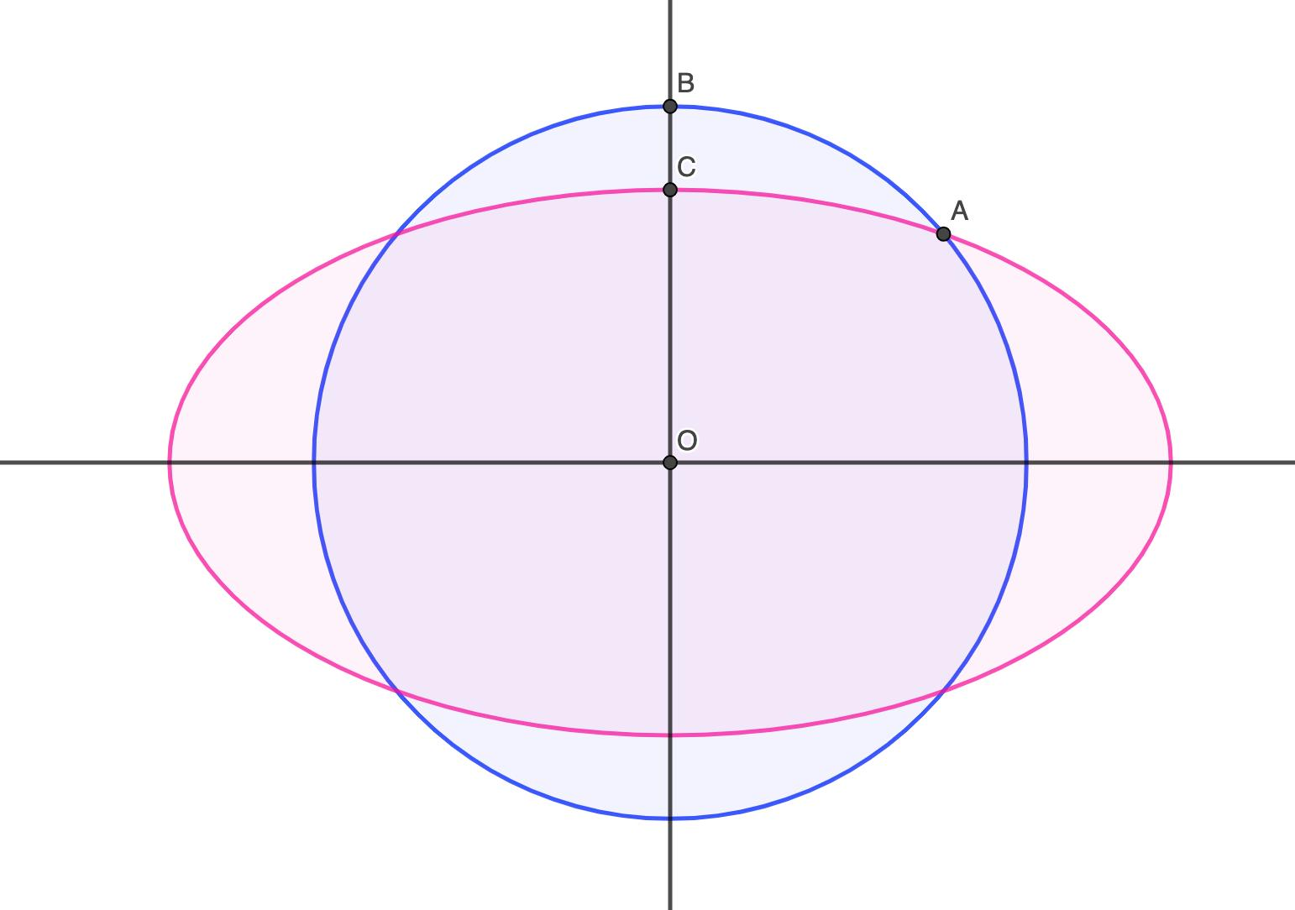
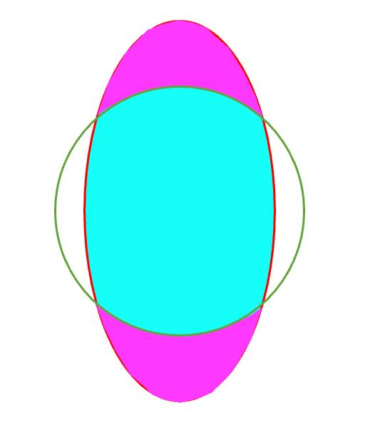
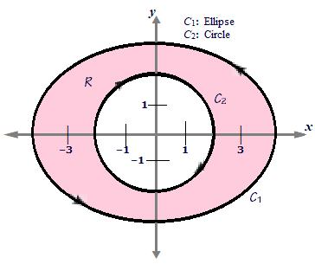
A Circular–Elliptical Mixed Shape combines circular arcs with elliptical arcs.
For example:
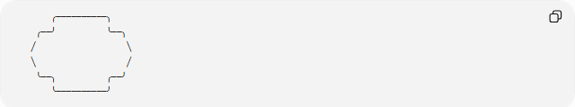
╭──────────╮
╭──╯ ╰──╮
╱ ╲
╲ ╱
╰──╮ ╭──╯
╰──────────╯
One part of the boundary may be circular while another is elliptical.
Mathematical representation
A boundary can be defined piecewise:
$$C=C_{\text{circle}}∪C_{\text{ellipse}}$$
The circular portion may satisfy:
$${\left(x-h\right)}^{2}+{\left(y-k\right)}^{2}=r^{2}$$
while the elliptical portion may satisfy:
$$\frac{{\left(x-h\right)}^{2}}{a^{2}}+\frac{{\left(y-k\right)}^{2}}{b^{2}}=1$$

Circular–Freeform Mixed Shapes
# Source: AI Source: Provided by: [Data Path: Persons Table -> ID Column: 1, Name_En Column: Motasem Essam] -> From: [ChatGPT] on [7/25/2026]
A Circular–Freeform Mixed Shape combines circular arcs with arbitrary freeform curves.
For example:
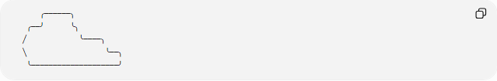
╭──────╮
╭──╯ ╰╮
╱ ╰────╮
╲ ╰──╮
╰────────────────────╯
One section may have a precise circular radius while another section is defined by a Bézier or spline curve.
This type is common in:
- product design
- architecture
- engineering
- computer graphics

Elliptical–Freeform Mixed Shapes
# Source: AI Source: Provided by: [Data Path: Persons Table -> ID Column: 1, Name_En Column: Motasem Essam] -> From: [ChatGPT] on [7/25/2026]
An Elliptical–Freeform Mixed Shape combines elliptical arcs with arbitrary freeform curves.
For example:
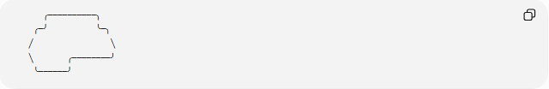
╭──────────╮
╭─╯ ╰─╮
╱ ╲
╲ ╭────────╯
╰──────╯
The elliptical portion follows a defined ellipse, while the freeform portion does not have to follow a standard geometric curve.

Wavy–Freeform Mixed Shapes
# Source: AI Source: Provided by: [Data Path: Persons Table -> ID Column: 1, Name_En Column: Motasem Essam] -> From: [ChatGPT] on [7/25/2026]
A Wavy–Freeform Mixed Shape combines wave-like curves with non-standard freeform curves.
For example:
●──╮ ╭──╮ ╭──────╮
╰──╯ ╰────╯ ╰──●
One portion may be approximately periodic:
$$y=Asin⁡\left(Bx+C\right)+D$$
while another portion can be represented by an arbitrary function or parametric curve.

Multi-Curve Mixed Shapes
# Source: AI Source: Provided by: [Data Path: Persons Table -> ID Column: 1, Name_En Column: Motasem Essam] -> From: [ChatGPT] on [7/25/2026]
A Multi-Curve Mixed Shape contains several different types of curves.
It may combine:
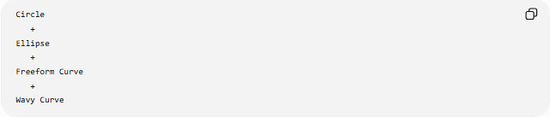
Circle
+
Ellipse
+
Freeform Curve
+
Wavy Curve
For example:
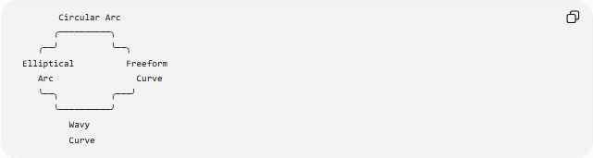
Circular Arc
╭──────────╮
╭──╯ ╰──╮
Elliptical Freeform
Arc Curve
╰──╮ ╭───╯
╰──────────╯
Wavy
Curve
This is useful for describing complex custom boundaries.

Curve–Straight Mixed Shapes
# Source: AI Source: Provided by: [Data Path: Persons Table -> ID Column: 1, Name_En Column: Motasem Essam] -> From: [ChatGPT] on [7/25/2026]
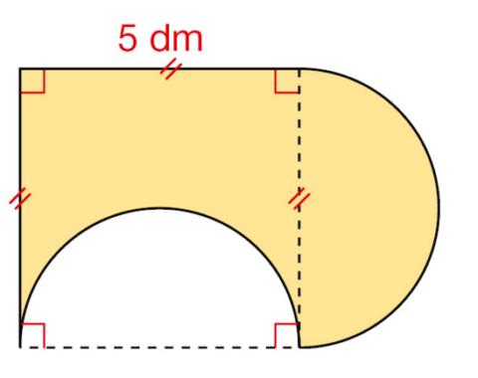
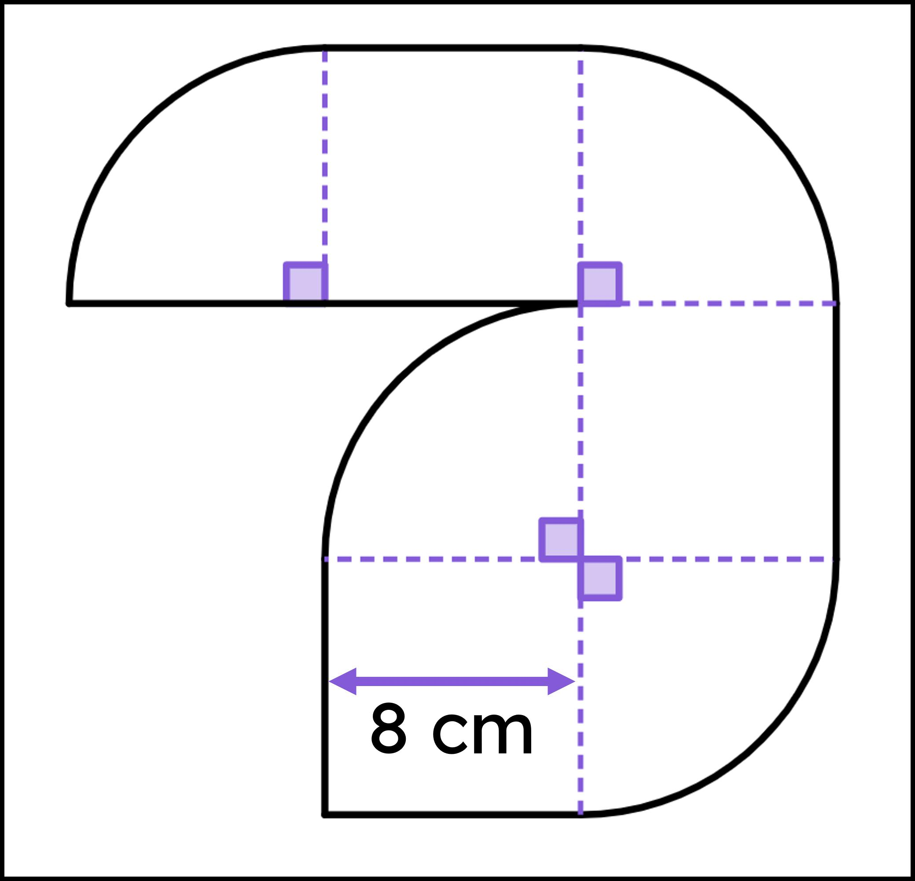
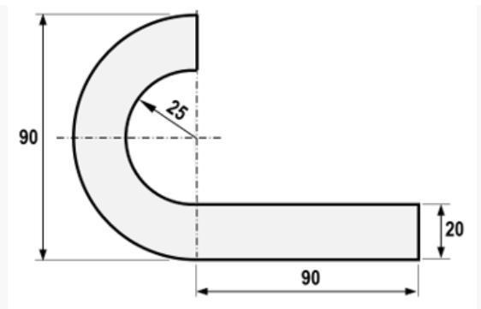
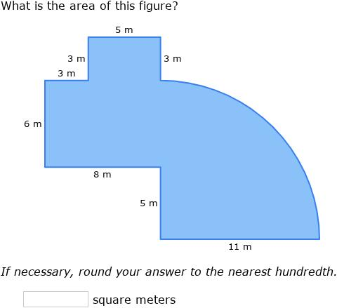
A Curve–Straight Mixed Shape contains both curved and straight boundary segments.
Examples include:
- semicircle attached to a rectangle
- circular arc joined to line segments
- elliptical arc with straight edges
- freeform curve connected to polygonal segments
A perimeter can be calculated as:
$$\boxed{P=L_{\text{curves}}+L_{\text{straight}}}$$
where:
$$L_{\text{curves}}=L_{1}+L_{2}+⋯+L_{m}$$
and:
$$L_{\text{straight}}=s_{1}+s_{2}+⋯+s_{n}$$

Complex Mixed Curvilinear Shapes
# Source: AI Source: Provided by: [Data Path: Persons Table -> ID Column: 1, Name_En Column: Motasem Essam] -> From: [ChatGPT] on [7/25/2026]
A Complex Mixed Curvilinear Shape combines several different curve types and may have complicated geometry.
It can contain:
- circular arcs
- elliptical arcs
- freeform curves
- wavy curves
- straight segments
- multiple enclosed regions
- holes or internal boundaries
The term complex is descriptive rather than a universally standardized mathematical classification.
If the boundary crosses itself, a more precise mathematical description is a self-intersecting curve or path.

Open Mixed Curvilinear Shapes
# Source: AI Source: Provided by: [Data Path: Persons Table -> ID Column: 1, Name_En Column: Motasem Essam] -> From: [ChatGPT] on [7/25/2026]
A mixed curvilinear shape can be open.
An open mixed curve has endpoints:
$$\boxed{r\left(a\right)≠r\left(b\right)}$$
For example:
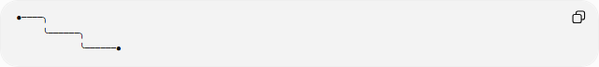
●────╮
╰──────╮
╰──────●
Different sections can use different curve types.

Closed Mixed Curvilinear Shapes
# Source: AI Source: Provided by: [Data Path: Persons Table -> ID Column: 1, Name_En Column: Motasem Essam] -> From: [ChatGPT] on [7/25/2026]
A Closed Mixed Curvilinear Shape has a boundary that returns to its starting point:
$$\boxed{r\left(a\right)=r\left(b\right)}$$
For a simple closed boundary, the curve encloses a region.
A closed boundary might consist of:
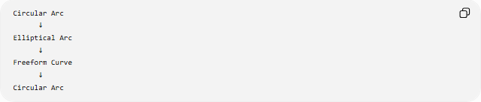
Circular Arc
↓
Elliptical Arc
↓
Freeform Curve
↓
Circular Arc
forming one continuous boundary.

Smooth Transitions
# Source: AI Source: Provided by: [Data Path: Persons Table -> ID Column: 1, Name_En Column: Motasem Essam] -> From: [ChatGPT] on [7/25/2026]
Different curve segments can meet in different ways.
Position Continuity
Two curves meet at the same point:
$$\boxed{r_{1}\left(c\right)=r_{2}\left(c\right)}$$
This gives C⁰ continuity.
Tangent Continuity
The curves also have matching tangent directions:
$$\boxed{r_{1}^{'}\left(c\right)∥r_{2}^{'}\left(c\right)}$$
This gives a visually smoother transition and is commonly associated with G¹ continuity.
Curvature Continuity
A higher-order transition can also match curvature.
This produces a more gradual visual change between curves.

Curvature
# Source: AI Source: Provided by: [Data Path: Persons Table -> ID Column: 1, Name_En Column: Motasem Essam] -> From: [ChatGPT] on [7/25/2026]
Different parts of a mixed curvilinear shape may have different curvature.
For:
$$y=f\left(x\right)$$
the curvature is:
$$\boxed{κ=\frac{∣f^{''}\left(x\right)∣}{{\left(1+{\left[f^{'}\left(x\right)\right]}^{2}\right)}^{3/2}}}$$
For a circular portion:
$$κ=\frac{1}{r}$$
which is constant.
For an elliptical or freeform portion, curvature is generally variable.
Therefore, a mixed shape can contain regions with:
$$\text{constant curvature}$$
and regions with:
$$\text{variable curvature}$$

Arc Length
# Source: AI Source: Provided by: [Data Path: Persons Table -> ID Column: 1, Name_En Column: Motasem Essam] -> From: [ChatGPT] on [7/25/2026]
For a parametric curve:
$$x=x\left(t\right), y=y\left(t\right)$$
the arc length is:
$$L=\int_{a}^{b}{\sqrt{{\left(\frac{dx}{dt}\right)}^{2}+{\left(\frac{dy}{dt}\right)}^{2}}} dt$$
For a composite boundary:
$$\boxed{L_{\text{total}}=L_{1}+L_{2}+⋯+L_{n}}$$
Each component can be measured according to its own geometry.
For example:
$$L_{\text{total}}=L_{\text{circular}}+L_{\text{elliptical}}+L_{\text{freeform}}$$

Area of a Closed Mixed Shape
# Source: AI Source: Provided by: [Data Path: Persons Table -> ID Column: 1, Name_En Column: Motasem Essam] -> From: [ChatGPT] on [7/25/2026]
For a simple closed parametric boundary:
$$x=x\left(t\right), y=y\left(t\right)$$
the enclosed area is:
$$\boxed{A=\frac{1}{2}\oint{(}\left.x dy-y dx\right)}$$
Alternatively, when the shape can be divided into simpler regions:
$$A_{\text{total}}=A_{1}+A_{2}+⋯$$
or:
$$A_{\text{total}}=A_{\text{outer}}-A_{\text{removed}}$$
depending on the construction.

Symmetry
# Source: AI Source: Provided by: [Data Path: Persons Table -> ID Column: 1, Name_En Column: Motasem Essam] -> From: [ChatGPT] on [7/25/2026]
Mixed curvilinear shapes may be:
- symmetric
- asymmetric
- partially symmetric
A mixed shape is symmetric under a transformation T when:
$$\boxed{T\left(S\right)=S}$$
Different components must correspond appropriately under the same transformation.
For example, a circular arc on one side may need a matching elliptical or freeform section on the other side for the entire shape to have symmetry.

Mixed Curvilinear vs Freeform Curvilinear
# Source: AI Source: Provided by: [Data Path: Persons Table -> ID Column: 1, Name_En Column: Motasem Essam] -> From: [ChatGPT] on [7/25/2026]
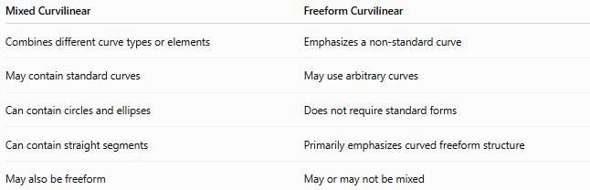
Mixed Curvilinear | Freeform Curvilinear
Combines different curve types or elements | Emphasizes a non-standard curve
May contain standard curves | May use arbitrary curves
Can contain circles and ellipses | Does not require standard forms
Can contain straight segments | Primarily emphasizes curved freeform structure
May also be freeform | May or may not be mixed
A shape can therefore be both mixed and freeform.

Mixed Curvilinear vs Smooth Curvilinear
# Source: AI Source: Provided by: [Data Path: Persons Table -> ID Column: 1, Name_En Column: Motasem Essam] -> From: [ChatGPT] on [7/25/2026]
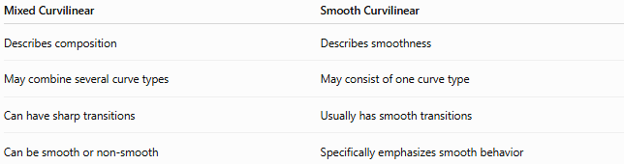
Mixed Curvilinear | Smooth Curvilinear
Describes composition | Describes smoothness
May combine several curve types | May consist of one curve type
Can have sharp transitions | Usually has smooth transitions
Can be smooth or non-smooth | Specifically emphasizes smooth behavior
Therefore:
$$\boxed{\text{Mixed}≠\text{Smooth}}$$
A mixed shape can be designed to be completely smooth, but being mixed does not automatically make it smooth.

Mixed Curvilinear vs Wavy Curvilinear
# Source: AI Source: Provided by: [Data Path: Persons Table -> ID Column: 1, Name_En Column: Motasem Essam] -> From: [ChatGPT] on [7/25/2026]
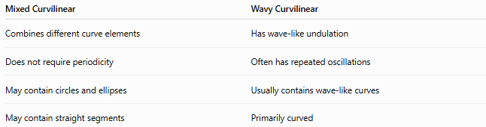
Mixed Curvilinear | Wavy Curvilinear
Combines different curve elements | Has wave-like undulation
Does not require periodicity | Often has repeated oscillations
May contain circles and ellipses | Usually contains wave-like curves
May contain straight segments | Primarily curved
A shape can be both mixed and wavy.

Classification Summary
# Source: AI Source: Provided by: [Data Path: Persons Table -> ID Column: 1, Name_En Column: Motasem Essam] -> From: [ChatGPT] on [7/25/2026]
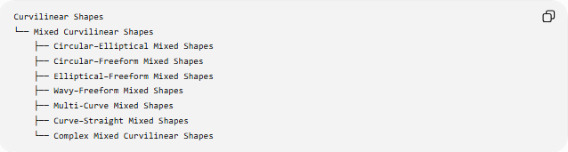
Curvilinear Shapes
└── Mixed Curvilinear Shapes
├── Circular–Elliptical Mixed Shapes
├── Circular–Freeform Mixed Shapes
├── Elliptical–Freeform Mixed Shapes
├── Wavy–Freeform Mixed Shapes
├── Multi-Curve Mixed Shapes
├── Curve–Straight Mixed Shapes
└── Complex Mixed Curvilinear Shapes
A more structural classification is:
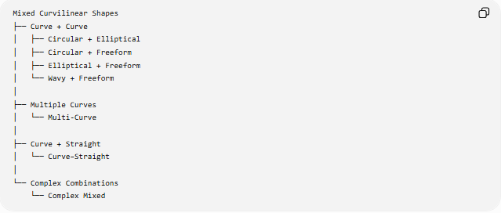
Mixed Curvilinear Shapes
├── Curve + Curve
│ ├── Circular + Elliptical
│ ├── Circular + Freeform
│ ├── Elliptical + Freeform
│ └── Wavy + Freeform
│
├── Multiple Curves
│ └── Multi-Curve
│
├── Curve + Straight
│ └── Curve–Straight
│
└── Complex Combinations
└── Complex Mixed

Key Points
# Source: AI Source: Provided by: [Data Path: Persons Table -> ID Column: 1, Name_En Column: Motasem Essam] -> From: [ChatGPT] on [7/25/2026]
- Mixed Curvilinear Shapes combine different curved elements or combine curved elements with other boundary elements.
- They may contain circular, elliptical, wavy, and freeform curves.
- They may also include straight-line segments.
- They can be open or closed.
- They can be smooth or have sharp transitions.
- Different portions can have different curvature.
- Their total perimeter is the sum of the lengths of their individual boundary components.
- Closed mixed shapes can have their area calculated using integration, Green's theorem, or decomposition into simpler regions.
- Mixed is a descriptive structural classification, not a single standardized mathematical shape category.
- A mixed curvilinear shape can simultaneously be freeform, smooth, symmetric, asymmetric, or wavy.

Conclusion
# Source: AI Source: Provided by: [Data Path: Persons Table -> ID Column: 1, Name_En Column: Motasem Essam] -> From: [ChatGPT] on [7/25/2026]
Mixed Curvilinear Shapes are composite forms that combine different types of curves or combine curved and straight boundary elements. They provide a flexible way to describe shapes that cannot be adequately classified as purely circular, elliptical, wavy, or freeform.
The central idea is:
$$\boxed{\text{Mixed Curvilinear Shape}=\text{Combination of Different Curve or Boundary Types}}$$
This completes the main classification:
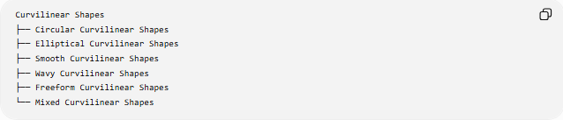
Curvilinear Shapes
├── Circular Curvilinear Shapes
├── Elliptical Curvilinear Shapes
├── Smooth Curvilinear Shapes
├── Wavy Curvilinear Shapes
├── Freeform Curvilinear Shapes
└── Mixed Curvilinear Shapes

